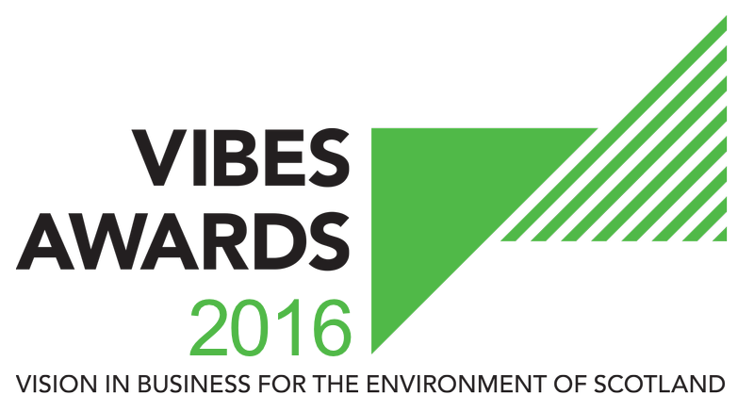

TRANSPORT AWARD

APPLICATION FORM

2016

Contents
1. How Does It Work? 2
2. Basic Information 3
3. Judging Criteria 7
4. Innovation Award 11
5. Green Team Award 12
6. Partners & Sponsors 13
7. Submission Details 14

Please read the guidance notes provided on the VIBES Website www.vibes.org.uk before completing the sections below.

How Does It Work?
The VIBES (Vision in Business for the Environment of Scotland) Awardsaim to raise awareness of environmental and sustainable development¹ issues within businesses in Scotland.
¹ “Development that meets the needs of the present without compromising the ability of future generations to meet their own needs” (Bruntland Report definition) i.e. takes consideration of social, economic and environmental issues.
The competition emphasises that best environmental practice is not only good for business, the economy and competitiveness, but that it also benefits the surroundings in which we work, live and relax. VIBES rewards those who have addressed sustainable development issues in the work place and encourages others to follow their examples.
The Transport Award recognises businesses that have achieved a significant, measurable reduction in their environmental impact through the introduction of sustainable transport practices.
This could include all types of businesses that use vehicles in their day to day operations. The organisation should be able to demonstrate a reduction in transport-related fuel consumption and consequent CO2 emissions. This could be through:
- Introducing a fuel efficient driving programme,
- Purchasing electric or fuel efficient vehicles,
- Fitting vehicles with telematics,
- Setting up a cycle to work scheme,
- Encouraging walking and public transport, installing technology that reduces the need to travel, such as conference call systems.
- Any other initiatives that have been implemented to reduce your transport impact on the environment.
Forms can be downloaded as a Word document from www.vibes.org.uk, completed electronically and submitted via e-mail to vibes@sepa.org.uk.
We encourage email entries, although you may prefer to complete forms manually. Please endeavour to write as clearly as possible and send paper copies to the address at the back of the form.
All the forms we receive will be assessed, and those which show a high level of commitment and have reached the appropriate standard will be added to the list of finalists.
If you are placed on the list of finalists, you will then receive a judges’ site visit. This gives you the opportunity to provide more details of your achievements and allows the judges to more accurately assess your application.
If your company has previously applied for or won a VIBES award, it is important that you can demonstrate continuous or additional improvement from the time of your previous application.
Please note we are limiting the finalists to a maximum of 5 per category for 2016.

Basic Information
Company Name
Candidate site*
Number of sites*
Number of employees at site*
Is your company part of a larger group?*
If yes, please provide the name of the larger group*
Number of employees in group*
Are you classed as a small to medium sized enterprise (SME)?**
* This information must be completed for a successful application
** SMEs are defined as having less than 250 employees.

Main Business Activities
Please describe briefly the main business activities taking place at the site.

This section should include details of your main business activity, the services or products you provide and your principal markets. This summary is limited to 100 words.

CONTACT INFORMATION
Site Contact*
Job Title*
Telephone Number*
Email Address*
Website*
Correspondence Address Including Postcode*
* This information must be completed for a successful application

These awards act as a participating feeder scheme for the European Business Awards for the Environment (EBAE).
If you are successful with your VIBES entry we will provide you with further information on the EBAE. You can read more about the European awards by visiting their website at: http://ec.europa.eu/environment/awards/index.html.
AWARDS
Are you happy for your application to be put forward as a potential UK entry for EBAE?
Have you applied for a VIBES award previously?
If ‘yes’, when and which award(s)?
Where did you hear about the VIBES Awards?

Please note that by entering VIBES you agree to share the information you provide with the partner organisations for judging purposes.
We may ask partner organisations for additional information. This information will only be used to help assess your suitability as a VIBES winner.
If you’re successful with your entry, we will prepare a case study to highlight the areas of your business that particularly impressed the judges. Once you have approved the content of the case study, it will be used to promote good practice more widely.
The partner organisations are:
- Energy Saving Trust
- Highlands and Islands Enterprise
- Scottish Environment Protection Agency
- Scottish Enterprise
- Scottish Water
- Scottish Government
- Zero Waste Scotland
- 2020 Climate Group
The Awards are supported by:
- CBI Scotland
- Institute of Directors
- Bright Green Business
- FSB
- Quality Scotland

Partner organisations, sponsors and supporting organisations may contact you with further information that they consider may be appropriate. Please indicate if you do not want to receive this information.
Please mark if you do not wish to receive information from partner organisations. | ☐
Please mark if you do not wish to receive information from sponsor organisations. | ☐
Please mark if you do not wish to receive information from supporting organisations. | ☐

Judging Criteria
We would like you to provide information on your company’s commitment to improving environmental performance, including actions and achievements. To help us assess your entry please supply details against the following criteria (see guidance notes for further information).
EXECUTIVE SUMMARY
Please explain why you are applying for this award outlining what you have done, what you have achieved, innovations, originality and inspiration for the changes.

This summary is limited to 500 words.
CRITERIA  Please identify word count in this box | COMMITMENT (250 words max)  Senior management must be clearly committed to the development and implementation of the sustainable transport practices. The importance in the context of the organisations overall strategy must be clear.

CRITERIA  Please identify word count in this box | INNOVATION (250 words max)  Innovation in the introduction of sustainable transport practices must bring improvements in environmental performance over comparable alternatives and promote more eco-efficient practices.

CRITERIA  Please identify word count in this box | ENVIRONMENTAL BENEFIT (250 words max)  Clear and quantifiable analysis must demonstrate the reduced environmental impacts of the sustainable transport practices and how environmental monitoring is used to inform development of the policy.  Please provide environmental data for 3 years if possible, and be sure to include the correct units where applicable

CRITERIA  Please identify word count in this box | SOCIAL BENEFIT (250 words max)  The sustainable transport practices should meet the needs of consumers, staff, and communities and bring wider social benefits.

CRITERIA  Please identify word count in this box | ECONOMIC BENEFIT(250 words max)  Proof must be provided to demonstrate that the introduction of sustainable transport practices is economically viable.  Please ensure that economic benefit data provided relates specifically to the environmental benefit data provided in the previous section.  Please provide data for three years if possible.

CRITERIA  Please identify word count in this box | BEST PRACTICE (250 words max)  There must be clear potential for good practice and innovation to be replicated elsewhere (e.g. through involvement in business networks, dissemination at conferences).

Innovation Award
2016 is Scotland’s Year of Innovation, Architecture and Design. This year The Innovation Award was introduced to recognise businesses that have developed, innovative products, practices or services that bring environmental and business benefits. This category highlights the ability of businesses to promote sustainable consumption, reduce environmental impacts and create new business opportunities. Please see the guidance notes for this category and fill in the box below if you would like to enter.
INNOVATION
Please explain why you are applying for this award providing:
- A summary of the circumstances leading to the development/implementation of the product/service
- Details of the specific innovative elements that distinguish it from what was being undertaken previously or other products/services already on the market
- Evidence that the product/service performs better than or as well as a comparable alternative and meets relevant safety standards – what monitoring and evaluation has been undertaken on the innovation.
- Evidence of any innovation support mechanisms accessed, if applicable, e.g. specialist support, grant support, innovation vouchers via Knowledge Transfer Networks, or advice on intellectual assets and protection.
- How does this innovation achieve environmental economic and social benefits.
This section is limited to 250 words.

Green Team Award
The Green Team Award rewards organisations that have recognised the importance of working as a team to deliver environmental improvements. A green team can be within an organisation or between organisations.
If you would like to be considered for this award category, please see the guidance notes for this category and fill in the section below.
CONTACT INFORMATION
Please identify the leader for your green team
Contact Name*
Job Title*
Telephone Number*
Email Address*
* This information must be completed for a successful application
GREEN TEAM
Please explain why you are applying for this award providing:
- Identification of green team and evidence that this includes staff from all levels within the organisation with demonstration of buy-in from senior management.
- Identification of written policy, responsibilities and targets for green team agreed with senior management.
- Examples of initiatives actioned by the Green Team that have impacted on the sustainability of the organisation.
- Evidence that the green team communicates effectively with the organisation and raises employee awareness of initiatives being undertaken.
- Evidence of wider benefits e.g. reduction in absenteeism, influencing others to embrace sustainability at work and at home.
This section is limited to 250 words.

Partners & Sponsors

Have you had contact with any of the VIBES Awards partners in the past?
If ‘yes’, please elaborate.
Are you happy for VIBES partners and sponsors to contact you in the future to offer advice/support?

Submission Details

To submit your completed application, save this word document using your company as the file name (if saving as PDF, please also provide a Word version). Then electronically submit this to us at the email address below.

Email Submission
vibes@SEPA.org.uk

Further Assistance
Help Desk 0300 0996699
vibes@sepa.org.uk
www.vibes.org.uk
Scottish Environment Protection Agency
VIBES Awards
Burnbrae
Mossilee Road
Galashiels
TD1 1NF

VIBES is a partnership between
Energy Saving Trust
Highlands and Islands Enterprise
Scottish Environment Protection Agency
Scottish Enterprise
Scottish Water
Scottish Government
Zero Waste Scotland
2020 Climate Group
VIBES is supported by
CBI Scotland
Institute of Directors
Bright Green Business
FSB
Quality Scotland

Good luck from the whole team!

