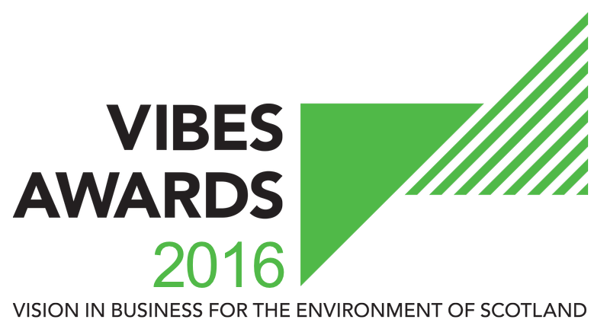

INNOVATION AWARD

APPLICATION FORM

2016

Contents

1. How Does It Work? 2
2. Basic Information 4
3. Judging Criteria 7
4. Partners & Sponsors 8
5. Submission Details 8

How Does It Work?

The VIBES (Vision in Business for the Environment of Scotland) Awardsaim to raise awareness of environmental and sustainable development¹ issues within businesses in Scotland.
¹ “Development that meets the needs of the present without compromising the ability of future generations to meet their own needs” (Bruntland Report definition) i.e. takes consideration of social, economic and environmental issues.
The competition emphasises that best environmental practice is not only good for business, the economy and competitiveness, but that it also benefits the surroundings in which we work, live and relax. VIBES rewards those who have addressed sustainable development issues in the work place and encourages others to follow their examples.
2016 is Scotland’s Year of Innovation, Architecture and Design. This encapsulate Scotland’s heritage and modern attributes in relation to architecture, engineering, renewables, fashion, textiles, science, technology and more
Innovation is crucial to the continuing success of any organisation. In order to achieve environmental sustainability, businesses need to innovate to develop more sustainable products, practices and services to reduce resources and minimise their environmental impact.
The Innovation Award recognises businesses, partnerships, collaborations and individuals that have developed innovative products, practices or services that bring environmental and business benefits. This category highlights the ability of businesses to promote sustainable consumption, reduce environmental impacts and create new business opportunities.
The innovation could be a novel way of, for example, product design; change of a process to re-use waste, heat, energy, water; product re-use, repair and remanufacture; innovative business models; effective supply chain and cross-sectoral collaboration to reduce waste and/or use of raw materials. It may also include a collaborative approach with other organisations or within your own organisation.
The technology can be, but does not have to be, new or high tech. The application can utilise an existing technology and /or modification of an existing technology for a new product or service. Entrants’ product may have already been developed and in the marketplace, or it may still be in the development stage.
This section will be evaluated on the following:
- A summary of the circumstances leading to the development/implementation the innovation.
- Details of the specific innovative elements that distinguish this approach from what was being undertaken previously or other products/services already on the market
- Evidence that the product/service performs better than or as well as a comparable alternative and meets relevant safety standards – what monitoring and evaluation has been undertaken on the innovation?
- Evidence of any innovation support mechanisms accessed, if applicable, e.g. specialist support, grant support, innovation vouchers via Knowledge Transfer Networks, or advice on intellectual assets and protection.
- How does this innovation achieve environmental economic and social benefits?
- Where this is an individual within the business – a demonstration of the environmental benefit to the business as a result of the innovation e.g reducing raw material use, change to process or product design
Where a product or service is still in development, please provide details of the stage reached and the next steps required to market the product/service. Try to include proof that there is market potential for the product/service. Please identify your organisation’s commitment to getting the product/service to market. Please provide and understanding of the market barriers and necessary development process for the technology, product or service. If the product is in the development stage a clear business plan should be provided to identify the economic benefit of this product and route to market.
Forms can be downloaded as a Word document from www.vibes.org.uk, completed electronically and submitted via e-mail to vibes@sepa.org.uk.
We encourage email entries, although you may prefer to complete forms manually. Please endeavour to write as clearly as possible and send paper copies to the address at the back of the form.
All the forms we receive will be assessed, and those which show a high level of commitment and have reached the appropriate standard will be added to the list of finalists.
If you are placed on the list of finalists, you will then receive a judge’s site visit. This gives you the opportunity to provide more details of your achievements and allows the judges to more accurately assess your application.
If your company has previously applied for or won a VIBES award, it is important that you can demonstrate continuous or additional improvement from the time of your previous application.
Please note we are limiting the finalists to a maximum of 5 per category for 2016.

Basic Information
Company Name
Candidate site*
Number of sites*
Number of employees at site*
Is your company part of a larger group?*
If yes, please provide the name of the larger group*
Number of employees in group*
Are you classed as a small to medium sized enterprise (SME)?**
* This information must be completed for a successful application
** SMEs are defined as having less than 250 employees.

Main Business Activities
Please describe briefly the main business activities taking place at the site.

This section should include details of your main business activity, the services or products you provide and your principal markets. This summary is limited to 100 words.

CONTACT INFORMATION
Site Contact*
Job Title*
Telephone Number*
Email Address*
Website*
Correspondence Address Including Postcode*
* This information must be completed for a successful application

These awards act as a participating feeder scheme for the European Business Awards for the Environment (EBAE).
If you are successful with your VIBES entry we will provide you with further information on the EBAE. You can read more about the European awards by visiting their website at: http://ec.europa.eu/environment/awards/index.html.
AWARDS
Are you happy for your application to be put forward as a potential UK entry for EBAE?
Have you applied for a VIBES award previously?
If ‘yes’, when and which award(s)?
Where did you hear about the VIBES Awards?

Please note that by entering VIBES you agree to share the information you provide with the partner organisations for judging purposes.
We may ask partner organisations for additional information. This information will only be used to help assess your suitability as a VIBES winner.
If you’re successful with your entry, we will prepare a case study to highlight the areas of your business that particularly impressed the judges. Once you have approved the content of the case study, it will be used to promote good practice more widely.
The partner organisations are:
- Energy Saving Trust
- Highlands and Islands Enterprise
- Scottish Environment Protection Agency
- Scottish Enterprise
- Scottish Water
- Scottish Government
- Zero Waste Scotland
- 2020 Climate Group
The Awards are supported by:
- CBI Scotland
- Institute of Directors
- Bright Green Business
- FSB
- Quality Scotland
Partner organisations, sponsors and supporting organisations may contact you with further information that they consider may be appropriate. Please indicate if you do not want to receive this information.
Please mark if you do not wish to receive information from partner organisations. | ☐
Please mark if you do not wish to receive information from sponsor organisations. | ☐
Please mark if you do not wish to receive information from supporting organisations. | ☐

Judging Criteria

INNOVATION
Please explain why you are applying for this award providing:
- A summary of the circumstances leading to the development/implementation of the product/service
- Details of the specific innovative elements that distinguish it from what was being undertaken previously or other products/services already on the market
- Evidence that the product/service performs better than or as well as a comparable alternative and meets relevant safety standards – what monitoring and evaluation has been undertaken on the innovation.
- Evidence of any innovation support mechanisms accessed, if applicable, e.g. specialist support, grant support, innovation vouchers via Knowledge Transfer Networks, or advice on intellectual assets and protection.
- How does this innovation achieve environmental, economic and social benefits.
This section is limited to 500 words.

Partners & Sponsors

Have you had contact with any of the VIBES Awards partners in the past?
If ‘yes’, please elaborate.
Are you happy for VIBES partners and sponsors to contact you in the future to offer advice/support?

Submission Details

To submit your completed application, save this word document using your company as the file name (if saving as PDF, please also provide a Word version). Then electronically submit this to us at the email address below.

Email Submission
vibes@SEPA.org.uk

Further Assistance
Help Desk 0300 0996699
vibes@sepa.org.uk
www.vibes.org.uk
Scottish Environment Protection Agency
VIBES Awards
Burnbrae
Mossilee Road
Galashiels
TD1 1NF

VIBES is a partnership between
Energy Saving Trust
Highlands and Islands Enterprise
Scottish Environment Protection Agency
Scottish Enterprise
Scottish Water
Scottish Government
Zero Waste Scotland
2020 Climate Group
VIBES is supported by
CBI Scotland
Institute of Directors
Bright Green Business
FSB
Quality Scotland

Good luck from the whole team!

