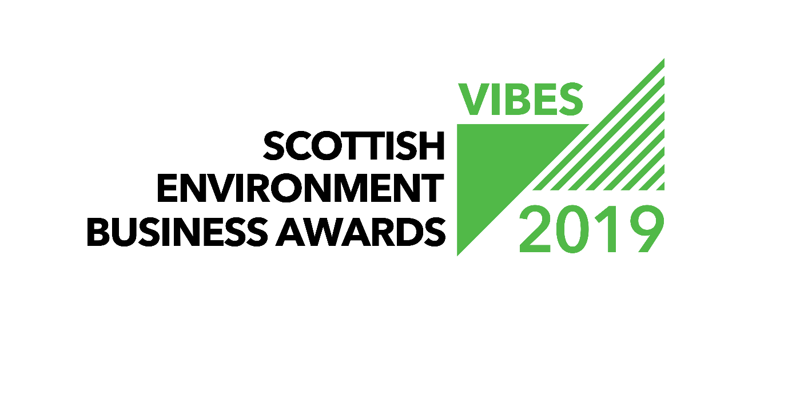
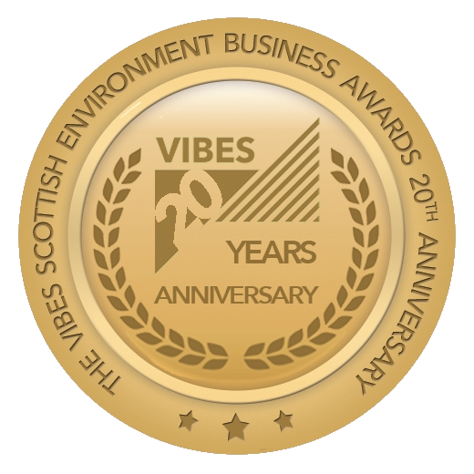

“BEST OF VIBES” AWARD

APPLICATION FORM

2019

Contents

1. General Information 2
2. Entry Form 3
3. Partners & Sponsors 5
4. Submission Details 7

General Information

Welcome to the VIBES – Scottish Environment Business Awards 2019. The awards aim to emphasise that best environmental practice is not only good for business, the economy and competitiveness, but that it also benefits the surroundings in which we work, live and relax. VIBES rewards those who have addressed sustainable¹ development issues in the work place and encourages others to follow their examples.
¹ “Development that meets the needs of the present without compromising the ability of future generations to meet their own needs” (Bruntland Report definition) i.e. takes consideration of social, economic and environmental issues.
2019 is VIBES 20th anniversary year. To celebrate this milestone, we have created a special “Best of VIBES” award open to all previous winners of a VIBES award. Applications are invited from winners of any category between 1999 and 2018.
To apply for this award, please tell us in no more than 500 words why you think your business deserves this top accolade. A judging panel will select the best 10 entries and these will be featured on the VIBES website, social media and via other opportunities throughout the 20th anniversary year. The winner will be selected via a public vote and announced at the VIBES Awards Ceremony 2019.
The Best of VIBES Award recognises past winners of VIBES that can demonstrate continuous environmental improvement and a contribution to Scotland’s sustainable development. We are looking for entries how can show alignment with the ethos of VIBES i.e. “what’s good for the environment is good for business”.
Applications will be assessed against a number of criteria including commitment, action and achievements in relation to environmental improvement over the longer term.
A business with a successful application will be able to provide an engaging story about the journey to be a VIBES winner and to where they are now.
Some information to include;
- The company commitment to sustainability
- Quantification of environmental and economic benefits and how these have helped business growth.
- Other achievements and benefits in relation to environmental improvement and winning a VIBES Award

Entry Form
Company Name
Contact*
Job Title*
Telephone Number*
Email Address*
Website*
Correspondence Address Including Postcode*
Candidate site*

Number of sites*
Number of employees at site*
Is your company part of a larger group?*
If yes, please provide the name of the larger group*
Number of employees in group*
Are you classed as a small to medium sized enterprise (SME)?**
When did you win a VIBES award?
What category was this for?
What is your industry SIC code?
* These boxes must be completed
** SMEs are defined as having less than 250 employees.

Main Business Activities
Please describe briefly the main business activities taking place at the site.

This section should include details of your main business activity, the services or products you provide and your principal markets. This summary is limited to 100 words.

BEST OF VIBES – SCOTTISH ENVIRONMENT BUSINESS AWARDS
Please tell us in no more than 500 words why you think you should win this award.
Your entry should demonstrate “that what’s good for the environment is good for business”. You should include information on your longer-term commitment to improved environmental performance, your actions and your achievements.

A business with a successful application will be able to provide an engaging story about their journey to being a VIBES winner to where you are now. Some information to include;

- The company commitment to sustainability
- Quantification of environmental and economic benefits and how these have helped business growth.
- Other achievements and benefits in relation to environmental improvement and winning a VIBES Award

This section is limited to 500 words.

Partners & Sponsors
Please note that by entering VIBES – Scottish Environment Business Awards you agree to share the information you provide with the partner organisations for judging purposes.
We may ask partner organisations for additional information e.g. compliance status. This information will only be used to help assess your suitability as a VIBES – Scottish Environment Business Awards winner.
If you’re successful with your entry, we will prepare a case study to highlight the areas of your business that particularly impressed the judges. Once you have approved the content of the case study, it will be used to promote good practice more widely.
The partner organisations are:
- Energy Saving Trust
- Highlands and Islands Enterprise
- Scottish Environment Protection Agency
- Scottish Enterprise
- Scottish Natural Heritage
- Scottish Water
- Scottish Government
- Zero Waste Scotland
The Awards are supported by:
- CBI Scotland
- Institute of Directors
- Bright Green Business
- Federation of Small Businesses
- Quality Scotland
- Scottish Council for Development and Industry
Partner organisations, sponsors and supporting organisations may contact you with further information that they consider may be appropriate to help you with further environmental improvements. Please indicate if you agree to receive this information.
Please mark if you agree to receive information from partner organisations. | ☐
Please mark if you agree to receive information from sponsor organisations. | ☐
Please mark if you agree to receive information from supporting organisations. | ☐

To maximise promotional opportunities your application will be shared with our PR contractor, BIG Partnership, who will be in touch with you for approval, should they wish to use any content from your entry in the media. This will result in press coverage for your business. Please tick box to agree to this.
Please mark if you agree to share your application with our PR contractor under conditions above. | ☐

Have you had contact with any of the VIBES – Scottish Environment Business Awards partners in the past?
If ‘yes’, please elaborate.

Submission Details
Forms can be downloaded as a Word document from www.vibes.org.uk, completed electronically and submitted via e-mail to vibes@sepa.org.uk.
To submit your completed application, save this word document using your company as the file name (if saving as PDF, please also provide a Word version). Then electronically submit this to us at the email address below.
We encourage email entries, although you may prefer to hand write forms. Please endeavour to write as clearly as possible and send paper copies to the address at the back of the form.
Applications must be submitted before 1st March 5pm.
Email Submission
vibes@SEPA.org.uk
Further Assistance
Help Desk 0300 0996699
vibes@sepa.org.uk
www.vibes.org.uk
Scottish Environment Protection Agency
VIBES Awards
Burnbrae
Mossilee Road
Galashiels
TD1 1NF
Good luck from the whole team!

